Lab 5: Simulating Y86-64 Program

1 Introduction
In this lab, you will learn about the implementation of a Y86-64 processor. When completing this lab, you will have a keen appreciation for the interactions between instruction and hardware that affect your programs. You will run two simple Y86-64 programs and become familiar with the Y86-64 tools.

2 Type

This is an individual project.

3 Instructions
- Find Sources List:
Make sure the link in sources.list match your ubuntu version:
For Ubuntu 14.10 utopic:
https://www.cnblogs.com/outs/p/5182390.html
For Other Ubuntu:
https://wiki.ubuntu.org.cn/%E6%BA%90%E5%88%97%E8%A1%A8
- Backup: sources.list.bak
# sudo cp /etc/apt/sources.list /etc/apt/sources.list.bak
- Modify: Rewrite sources.list using source from the website.
# sudo gedit /etc/apt/sources.list
- Update:
# sudo apt-get update (upgrade / -f install)
# sudo apt-get install flex bison
For Ubuntu18、16、14:
# sudo apt-get install tcl8.5 tcl8.5-dev tk8.5 tk8.5-dev
For Ubuntu20 and later:
# sudo apt-get install tcl tcl-dev tk tk-dev
For Ubuntu18、16、14:
In sim and seq directory, find Makefile, and modify it:
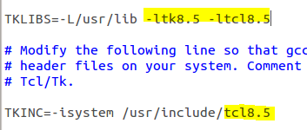
For Ubuntu20 and later:
In sim and seq directory, find Makefile, and modify it:
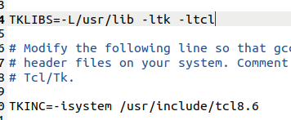

In seq directory, find ssim.c, and modify all interp->result to Tcl_SetResult() and Tcl_GetStringResult(). Refer to
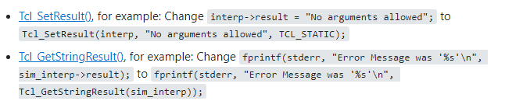
https://stackoverflow.com/questions/66291922/tk-h-looks-for-tcl-h-in-usr-include-but-tcl-h-is-in-usr-include-tcl-i-dont-h
Find and comment out the lines include “matherr”:
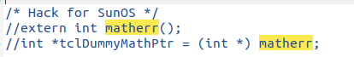
For Ubuntu22:
In misc and pipe directory, find Makefile, and modify it:
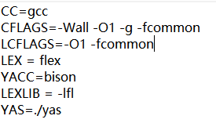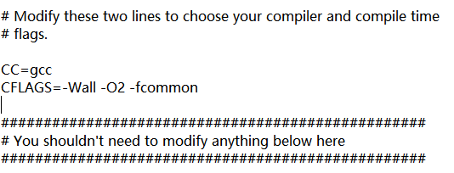
https://stackoverflow.com/questions/63152352/fail-to-compile-the-y86-simulatur-csapp

- Start by copying the Lab3 to a directory in which you plan to do your work.
- Unpacked the file using:
# tar xvf sim.tar (Or just double click and choose extract)
The directory sim contains the following subdirectories:
misc Source code files for utilities such as YAS (the Y86-64 assembler), and YIS (the Y86-64 instruction set simulator). It also contains the isa.c source file that is used by all of the processor simulators.
y86-code Y86-64 assembly code for many of the example programs. As a running example, we will use the program asum.ys in this subdirectory. The compiled version of the program is shown in Figure 1.
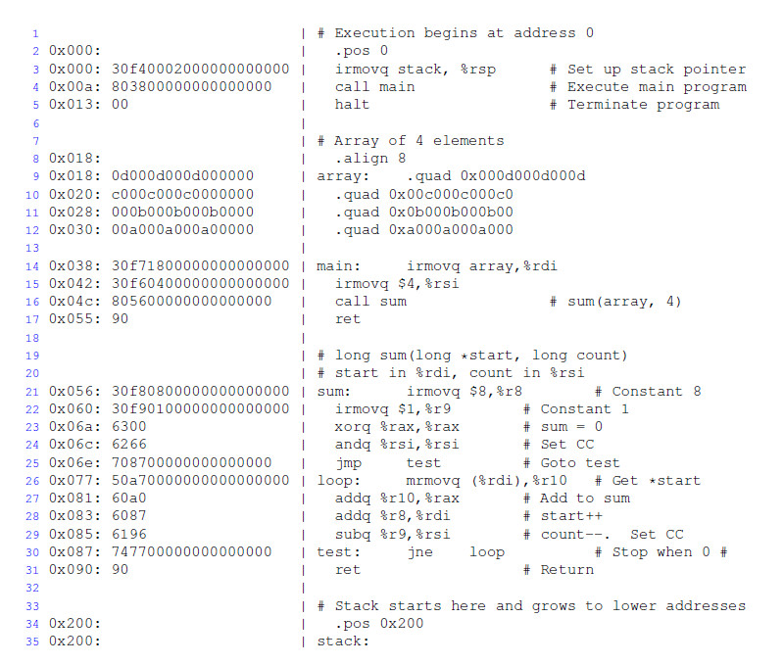
Figure 1 Sample object code file. This code is in the file asum.yo in the y86-code subdirectory.
- Change to the sim directory and build the Y86-64 tools:
# make clean
# make
- For the Y86-64processor, the simulator can be run in TTY or GUI mode:
TTY mode Uses a minimalist, terminal-oriented interface. Prints everything on the terminal output. Not very convenient for debugging but can be installed on any system and can be used for automated testing. The default mode for all simulators.
GUI mode Has a graphic user interface, to be described shortly. Very helpful for visualizing the processor activity and for debugging modified versions of the design. Requires installation of Tcl/Tk on your system. Invoked with the -g command line option. Running in GUI mode is only possible from within the directory (seq) in which the executable simulator program is located.
For the simulator, you can specify several options from the command line:
-h Prints a summary of all of the command line options.
-g Run the simulator in GUI mode (the default is TTY mode).
-t (TTY mode only) Runs both the processor and the ISA simulators, comparing the resulting values of the memory, register file, and condition codes. If no discrepancies are found, it prints the message ‘ISA Check Succeeds.’ Otherwise, it prints information about the words of the register file or memory that differ.
-l m (TTY mode only) Sets the instruction limit, executing at most m instructions before halting (the default limit is 10000 instructions).
-v n (TTY mode only) Sets the verbosity level to n, which must be between 0 and 2 with a default value of 2.
If you are running in GUI mode, you’ll need to install Tcl/Tk alongwith the Tcl and Tk developer's packages.
(5) In seq directory, use following command to open GUI:
# make clean
# make ssim VERSION=std
# ./ssim -g ../y86-code/asum.yo
This code runs SSIM in GUI mode, executing the instructions in object code file asum.yo from the y86-code subdirectory.
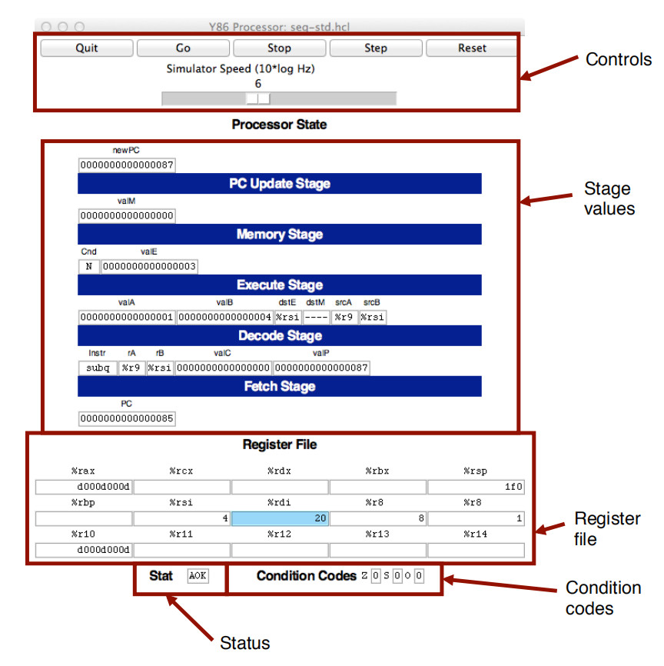
Figure 2 Main control panel for SEQ simulator
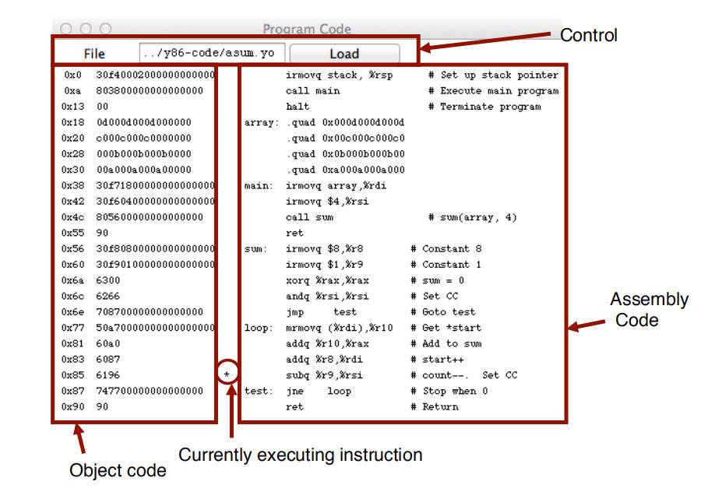
Figure 3 Code display window for SEQ simulator

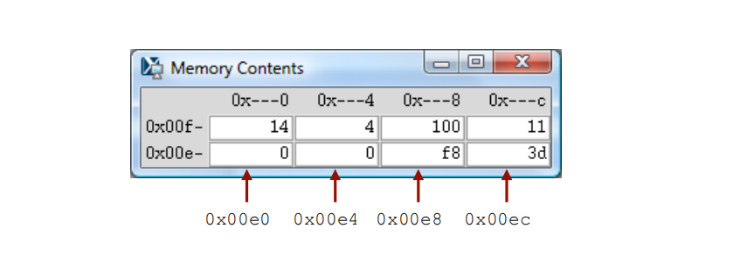
Figure 4 Memory display window for SEQ simulator
The main control window (Figure 2) contains buttons to control the simulator as well as status information about the state of the processor. The different parts of the window are labeled in the figure:
Control: The buttons along the top control the simulator. Clicking the Quit button causes the simulator to exit. Clicking the Go button causes the simulator to start running. Clicking the Stop button causes the simulator to stop temporarily. Clicking the Step button causes the simulator to execute one instruction and then stop. Clicking the Reset button causes the simulator to return to its initial state.
The slider below the buttons controls the speed of the simulator when it is running. Moving it to the right makes the simulator run faster.
Stage values: This part of the display shows the values of the different processor signals during the current instruction evaluation. The main difference is that the simulator displays the name of the instruction in a field labeled Instr, rather than the numeric values of icode and ifun. Similarly, all register identifiers are shown using their names, rather than their numeric values, with “----” indicating that no register access is required.
Register file: This section displays the values of the 15 program registers. The register that has been updated most recently is shown highlighted in light blue. Register contents are not displayed untilafter the first time they are set to non zero values.
Remember that when an instruction writes to a program register, the register file is not updated until the beginning of the next clock cycle. This means that you must step the simulator one more time to see the update take place.
Stat: This shows the status of the current instruction being executed. The possible values are:
AOK: No problem encountered.
ADR: An addressing error has occurred either trying to read an instruction or trying to read or write data. Addresses cannot exceed 0x0FFF.
INS: An illegal instruction was encountered.
HLT: A halt instruction was encountered.
Condition codes: These show the values of the three condition codes: ZF, SF, and OF.
Remember that when an instruction changes the condition codes, the condition code register is not updated until the beginning of the next clock cycle. This means that you must step the simulator one more time to see the update take place.
Example:
The processor state illustrated in Figure 2 is for the first execution of line 29 of the asum.yo program shown in Figure 1. We can see that the program counter is at 0x085, that it has processed the instruction addq %r8, %rdi, that register %rax holds 0xd000d000d, the sum of the first array element, and %rsi holds 4, the count that is about to be decremented. Register %rdi holds 0x020, the address of these cond array element. There is a pending write of 0x03 to register %rsi (since dstE is set to %rsi and valE is set to 0x03). This write will take place at the start of the next clock cycle.
The window depicted in Figure 3 shows the object code file that is being executed by the simulator. The editbox identifies the file name of the program being executed. You can edit the file name in this window and click the Load button to load a new program. The left hand side of the display shows the object code being executed, while the right hand side shows the text from the assembly code file. The center has an asterisk(*) to indicate which instruction is currently being simulated. This corresponds to line 29 of the asum.yo program shown in Figure 1.
The window shown in Figure 4 shows the contents of the memory. It shows only those locations between the minimum and maximum addresses that have changed since the program began executing. Each row shows the contents of two memory words. Thus, each row shows 16 bytes of the memory, where the addresses of the bytes differ in only their least significant hexadecimal digits. To the left of the memory values is the“root” address, where the least significant digit is shown as “-”. Each column then corresponds to words with least significant address digits 0x0, and 0x8. The example shown in Figure 4 has arrows indicating memory locations 0x01f0 and 0x01f8.
The memory contents illustrated in the figure show the stack contents of the asum.yo program shown in Figure 1 during the execution of the sum procedure. Looking at the stack operations that have taken place so far, we see that %rsp was initialized to 0x200 (line 3). The call to main on line 4 pushes the return pointer 0x013, which is written to address 0x01f8. Procedure main calls sum (line 16), causing the return pointer 0x055 to be written to address 0x01f0. That accounts for all of the words shown in this memory display, and for the stack pointer being set to 0x01f0.
(6) You will be working in directory sim/misc in this part. Your task is to simulate the following two Y86-64 programs. The required behavior of these programs is defined by the example C functions in sim\misc\examples.c.
(6.1) sum.ys: Iteratively sum linked list elements
Simulate a Y86-64 program sum.ys that iteratively sums the elements of a linked list. It consists of some code that sets up the stack structure, invokes a function, and then halts. In this case, the function should be Y86-64 code for a function (sum list) that is functionally equivalent to the C sum list function in Figure 1.
(6.2) rsum.ys: Recursively sum linked list elements
Simulate a Y86-64 program rsum.ys that recursively sums the elements of a linked list. It is similar to the code in sum.ys, except that it uses a function rsum list that recursively sums a list of numbers.
(7) Testing the program. The Y86-64 assembler takes a Y86-64 assembly code file with extension .ys and generates a file with extension .yo. Put rsum.ys and sum.ys into misc directory. Use command:
# make sum.yo
# make rsum.yo
And then run the program in seq directory using:
# ./ssim -g ../misc/sum.yo
# ./ssim -g ../misc/rsum.yo
(8) For the programs sum.ys and rsum.ys, the result will be shown in register %rax with the sum of 0xcba.
(9) Explain the function and processor state of each step in the source file of sum.ys and rsum.ys according to your snapshot.

4 Handin

Results, Snapshots and Codes are inserted into Lab Report. You can hand in before the deadline.

This document describes the processor simulator that accompany the presentation of the Y86-64 processor architecture in Chapter 4 of our textbook. It is edited by the previous TAs.

